Traditional  Stories |  | 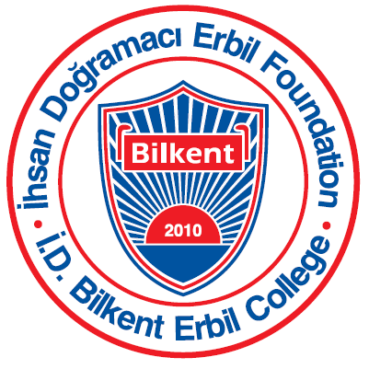
Grade 2 Unit of Inquiry October-November 2016
Unit of Inquiry
Central Idea: Traditional Stories tell us about cultures and beliefs from around the world.

Lines of inquiry:  - What stories are  - What traditional stories are  - How stories are told  - What traditional stories can tell us | Learning experiences:  - Students will be looking at different elements in stories and identifying what makes them traditional  - Students will use stories to help them understand differences in cultures and beliefs.  - Students will develop an appreciation for diversity and the richness of stories around the world.
Language
For language activities in this unit, students will:
- Read a variety of stories from different cultures and discuss character, plot and purpose.
- Discuss the ways different people or characters are represented in texts.
- Identify the key components to different types of traditional stories (folktales, fairy tales, fables, myths and legends).
- Complete in depth studies based on selected stories and cultures to identify values and cultural beliefs unique to that culture.
- Listen to storytellers and recount the story we heard to identify the type of traditional story.
- Identify the many ways stories have been told over the centuries.
- Use a checklist to identify a genre.
- Use poetry to identify and understand different language features.
- Write a traditional story.
- Create a play or puppet show of a traditional story for an audience.

Math
For math activities in this unit, students will:
- Continue developing number skills- place value, number patterns to 100.
- Partitioning numbers and number bonds to 100.
- Base ten and ten frames for organizing and thinking about number.
- Using a number line for addition and subtraction.
- Addition and Subtraction strategies such as counting on, counting back, double+1, making ten to add
- Finding the nearest ten by rounding up and rounding down
- Working with money to make 100 (British pounds and US dollars)
- Number of the Day strategies
- Learning to decide if something is likely or unlikely to happen; if it is impossible or possible and learning to make an educated guess.

PE
- Integrated unit: students will be taking music and stories from homeroom class and using movement and space to re-tell the story Turkısh, Turkman, Arabic and Kurdısh dance

Arts
- Students learn how traditional stories are told through art
- Students learn about different children book illustrators and their art techniques

ICT
- Students will create stories and poems using online book making website www.storybird.com
Music
- Students will create music for a traditional story.
- Students will use different instruments and materials to demonstrate rhythm and timing.
Library
- Students will visit the library once a week and they will borrow and change books. During this unit we will encourage students to discuss details about the books they choose to read and form opinions about characters and stories.

Announcement
Upcoming Dates:
- Parent-Teacher Conferences – October 26 and 27
- Fall break – October 27 at noon – November 6

