Who We Are |  | 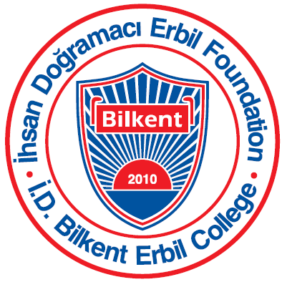
Grade 2 Unit of Inquiry August-October 2016
Unit of Inquiry
Central idea: The choices people make affect their health and well-being.

Lines of inquiry:  - What choices are  - How we make choices  - How choices affect our health and well- being | Learning experiences:  - Field Trips to learn about healthy bodies, and healthy choices.  - Interviews about lifestyle choices.  - Experiments and Investigations in school to identify how our choices affect our health.
Language:
- Students find out about the elements of narratives and recounts
- Students will read variety of narratives and recount texts
- Students learn to differentiate fact and opinion
- Students learn how to write for a purpose (stories, journals, letters, etc.)
Math:
- Use graphs and charts to show results
- Organize and interpret graphs
- Counting to 3-digit numbers
- Place values
Arts:
- Use of different techniques of art
- How to use each technique
- Students learn artists who uses different art techniques
ICT:
- How do we make good choices when we research online
- Learn about ethics and literacy
- Safe and responsible use of computer

Music:
- Making good choices.
- Evaluating their performance.
- Playing percussion instruments in rhythm.

PE:
- Exercises we do to make our bodies stronger
- Muscles we work when we exercise
- Changes exercise makes in our body

Library:
- G2 students will visit the library once a week and they will borrow and change books. yThere will be other activities during the year.

Upcoming events:
- August 23: Orientation for parents and students
- August 24/25/28: First days of school (8:30 till 12:00)
- September 7: Curriculum Information Evening
- September 21: Back to School Evening
- September 13/15: Kurban Bayram
- October 19/20: Parent Teacher Conference

