Science in Everyday Life |  | 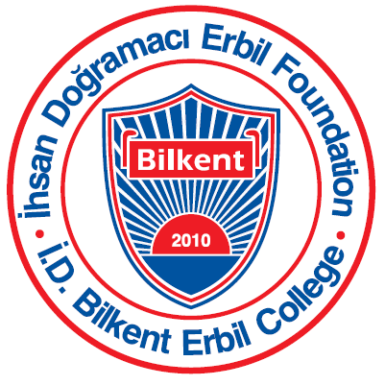
Grade 2 Unit of Inquiry December – January
Unit of Inquiry
Central idea: Materials behave and interact in certain ways, which determine how people use them.
Lines of inquiry:  - Behavior of materials  - Changing properties of materials  - Manipulation and application of materials to new purposes | Learning experiences:  - Students investigate the different properties of materials  - Students investigate the uses of the properties of materials  - Students conduct experiments to investigate how materials can be changed  - Students conduct research to find out how matter changes and how knowledge of this is applied in real life  - Students visit places to gain firsthand experience of practical applications of changes in matter
Language:
- Students read and analyze procedural texts.
- Students learn how to follow and give procedures, orally and in writing.
- Students learn processes and strategies of writing, recognizing, and explaining procedural texts.
Math:
- Standard and non-standard measurement
- Unit of measurement
- Measurement tools
- Applying mathematical concepts to cooking
- Ongoing: Addition and subtraction of numbers
PE:
- Students will understand specific techniques related to running, throwing, and jumping allows us to improve upon our personal results in Athletics

Arts:
- Students will explore uses of different materials in art and create 3D work.
- Students will learn how materials can be changed and how changes in materials are applied in arts.
ICT:
- Using the internet to gather information
Music:
- Students will made instruments with different materials.
- They will play their own instruments which they create them with their music.

Reminders: | Dates to remember:
Parents are encouraged to volunteer to demonstrate cooking to the class. Please send your available schedule to the homeroom teacher. | December 17: Start of holiday (Half day)  January 10: Return from holiday

